Retrouvez les lettres manquantes !!

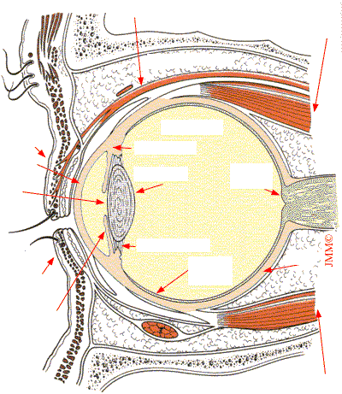

**Rappels anatomiques:**

**l'oeil**

o_ fr_nt_l

Gr_ _ss_ _rb_t_ _r_

_au_iè_e

_u_é_ieu_e

_au_iè_e

i_ _é_ieu_e

Cr_st_ll_n

Z_n_l_ de Z_nn

R_t_n_

_ _o_oï_e

N_rf

_pt_q_ _

Scl_r_

M_scl_ dr _it _u_é_ieu_

M_scl_ r_l_v_ _r de la _au_iè_e _u_é_ieu_e

c_rn_ _

p_p_ll_

_r_s

C_rps v_tr_

C_rps _i_iai_e

M_scl_ dr_ _t i_ _é_ieu_